Lilian Holm Wellness
Physical therapy and Wellness coaching
_______________________________________________________
MEDICAL SCREENING QUESTIONNAIRE

Name:________________________________________DOB:____________Date:______
Gender: M F Age:________ Occupation:_______________________Pregnant: Y N

Past Surgical History:______________________________________________________

Current Medications:_______________________________________________________

Have you had an X-ray, MRI or other tests?____________________________________

Are you experiencing any of the following? (circle any that apply, underline if a close relative (parents, siblings has been diagnosed with any of the following)

Cancer Diabetes Kidney disease Stroke
High blood pressure Heart disease Angina/Chest pain Ulcers
Osteoporosis Osteoarthritis Rheumatoid arthritis Fibromyalgia
Allergies/Asthma Lung disease Liver disease Sexually transmitted disease

Unexplained weight loss Fever/chills/sweats Bowel or bladder function change (incl.leaking)
Depression Changes in appetite Poor balance/falls Loss of menstrual period
Weakness Nausea/vomiting Difficulty swallowing Shortness of breath
Numbness/tingling Dizziness Night pain Headaches

or pain correlated with eating, fasting, urinating, defecating, sleeping, coughing, breathing, recent travel

Do you take blood thinners? Y N Do you take osteoporosis drugs? Y N
Are you allergic to latex? Y N Have you had a recent illness?__________________

CURRENT SYMPTOMS:

Where are you having symptoms?____________________________________________

When did your symptoms start?______________________________________________
How?(gradually, suddenly, injury):____________________________________________

My symptoms are currently(circle): getting better /about the same/getting worse

Have you received any treatment for this problem? (please describe type and

outcome):________________________________________________________________

Have you had this problem before? If so, please describe duration and

treatment:________________________________________________________________
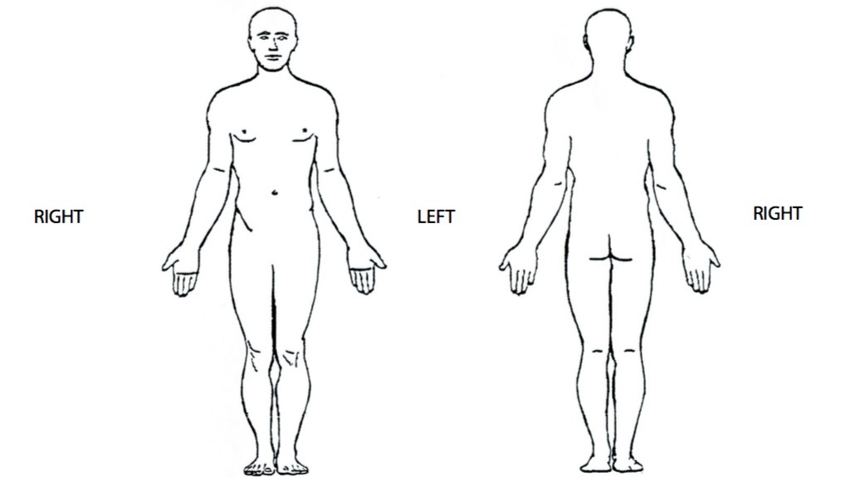
Please mark the areas where you feel pain on the figure below. Please circle on the scale below the numbers which best represents the average, lowest and worst severity of your pain over the last 48 hours.
No pain = 0 1 2 3 4 5 6 7 8 9 10 = Worst imaginable pain

Please mark numbness or tingling with N or T in the area where they occur

What makes your symptoms better?__________________________________________

What makes your symptoms worse?__________________________________________

Best and worst times of day?________________________________________________

What is your goal for treatment?_____________________________________________

List functional activities you are currently unable to perform, or are severely limited, due

to your symptoms._____________________________________________________

Do you limit activity or avoid certain positions in order to avoid pain or worsening? Y N

Over the past two weeks, have you felt hopeless or depressed, or the loss of interest or

pleasure in doing things? Yes No

If yes, would you like to have help with this? Yes No

